
COMPUTER SCIENCE AND ENGINEERING
Nov – 2026
ASSIGNMENT – 1
Course Code : CSA6303
Course Name : THREAT INTELLIGENCE AND NETWORK SECURITY
Student Name : L.Deepthi (192411213)
Max Marks: 50
Answer all the Questions
1 | A regional hospital network stores patient records, runs an online appointment portal and uses networked diagnostic machines. In one month the hospital faces four incidents: (i) an employee e-mails a spreadsheet of patient details to the wrong recipient, (ii) ransomware encrypts the records server, (iii) a technician alters a lab report without authorisation, and (iv) a flood of requests makes the appointment portal unreachable. Apply the fundamentals of network security to this case. Explain the three goals of the CIA triad and the related goals of authentication, non-repudiation and accountability; map each incident to the goal or goals that it violates with a reason; and prepare a table that gives, for each goal, two preventive controls and one detective control that the hospital should adopt. Discuss how the hospital should balance the three goals when they conflict (for example, tight access control versus emergency access to records). | (10) | (CO1) | (BL3)
2 | An online shopping company discovers that an attacker first sent a phishing e-mail to a customer-support agent, used the stolen password to log in to the internal network, moved across to the order database server, and copied customer data to an external server. Analyse the incident by classifying the types of network threats involved (malware, phishing, spoofing, sniffing, man-in-the-middle, denial of service, SQL injection and insider threats), stating which of them are passive and which are active, and identifying the likely threat actor (cybercriminal, hacktivist, nation-state or insider) with reasons. Prepare an attack-chain table that gives, for each stage, the threat, the weakness exploited, the impact on confidentiality, integrity or availability, and one control that would have stopped or detected the attack at that stage. Discuss which weaknesses were technical and which were human or procedural. | (10) | (CO1) | (BL4)
3 | A security analyst at a mid-size company notices that the firewall log shows 300 failed login attempts to the VPN gateway within ten minutes from one external IP address, and that the same address appears in a public threat-sharing report as part of a credential-stuffing campaign. Using this example, explain what threat intelligence is and how it differs from raw data and information, by showing how the log entry is converted step by step into actionable intelligence. Describe the characteristics of good threat intelligence (timely, accurate, relevant, contextual and actionable), explain how threat intelligence changes a security team from reactive to proactive, and discuss the benefits and the limitations (for example, false positives, information overload and stale indicators) of using threat intelligence in cybersecurity. | (10) | (CO1) | (BL3)
4 | A retail chain learns that a competitor has suffered a point-of-sale malware breach. The security manager must decide how to respond and wants to present suitable threat intelligence to three groups: the Chief Information Security Officer and the board, the SOC manager, and the incident handlers and network administrators. Analyse how strategic, tactical and operational threat intelligence apply to this situation. For each type, state the question that it answers, the audience, the time horizon and the sources, and give one deliverable that you would prepare for this case (for example, a risk briefing, a report of attacker techniques and tools, a warning about an expected campaign, and a list of technical indicators). Classify the following items as strategic, tactical or operational with a reason: an annual report on ransomware trends in retail, a description of how the attacker moves from stolen vendor credentials to the POS servers, an advance warning of a planned attack on the retailer's holiday sales, and a list of malicious domains. Discuss what the company would lose if it relied on only one type. | (10) | (CO1) | (BL4)
5 | A software-as-a-service company wants to set up a threat intelligence capability and begins with the requirement: "Are we likely to be targeted by credential-stuffing and ransomware groups in the next six months?" Evaluate how the threat intelligence lifecycle can be applied to answer this requirement. Describe the activities, tools and outputs of the planning and direction, collection, processing, analysis, dissemination and feedback phases, including how priority intelligence requirements are written and how information-sharing markings such as the Traffic Light Protocol are used. Then evaluate the applications of threat intelligence in the IT industry (for example, incident response, threat hunting, vulnerability and patch prioritisation, third-party risk assessment and executive risk reporting), and recommend four measures (for example, mean time to detect, mean time to respond, the percentage of alerts enriched with intelligence and the false-positive rate) to judge whether the programme is delivering value. | (10) | (CO1) | (BL5)
NAME : L.DEEPTHI (192411213)
ANSWERS

QUESTION 1 – FUNDAMENTALS OF NETWORK SECURITY
Case: A regional hospital experiences accidental disclosure of patient data, ransomware, unauthorised modification of a lab report and an unavailable appointment portal.

1. Three goals of the CIA triad
The CIA triad is the basic model used to protect information and systems. It contains confidentiality, integrity and availability.
- Confidentiality: Patient information must be seen only by authorised people. Examples include role-based access, encryption and secure sharing.
- Integrity: Records must remain correct, complete and unaltered unless an authorised person makes a valid change. Hashes, digital signatures and audit logs help protect integrity.
- Availability: Records and services must be accessible to authorised users when needed. Backups, redundancy, disaster recovery and denial-of-service protection support availability.

2. Related security goals
- Authentication: Confirms the identity of a user, device or service, for example through passwords plus multi-factor authentication (MFA).
- Non-repudiation: Provides evidence that a person performed an action so that they cannot reasonably deny it later. Digital signatures and protected transaction records can support it.
- Accountability: Makes actions traceable to a unique user or system through individual accounts, timestamps, audit trails and monitoring.
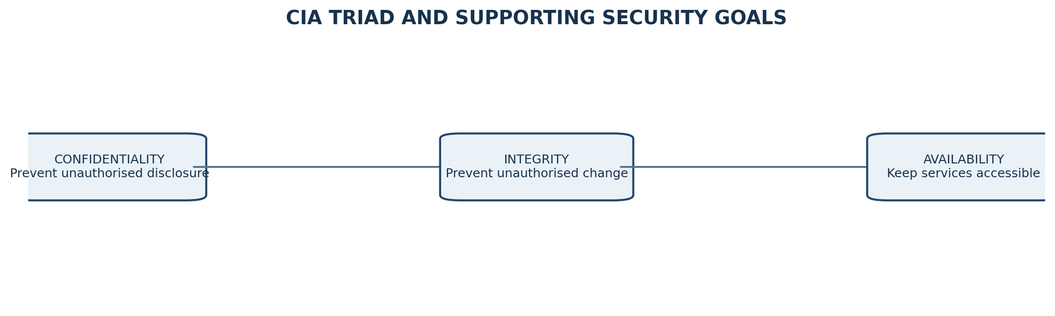
Figure 1. The CIA triad and its central purpose.

3. Mapping the four incidents to security goals
Incident | Goal(s) violated | Reason
Employee emails patient spreadsheet to wrong recipient | Confidentiality; possibly accountability | Unauthorised recipient receives private patient data. Accountability is weak if the sender/action cannot be reliably traced.
Ransomware encrypts records server | Availability and integrity; confidentiality if data is also stolen | Staff cannot access records. Encrypted or damaged records are no longer reliably usable; data theft would also expose confidentiality.
Technician alters lab report without authorisation | Integrity; accountability; possibly non-repudiation | The report is no longer trustworthy. Individual access logs and signed records are needed to identify and prove who changed it.
Flood of requests makes appointment portal unreachable | Availability | Legitimate patients cannot use the service because resources are exhausted, consistent with a denial-of-service attack.

4. Controls the hospital should adopt
Goal | Two preventive controls | One detective control
Confidentiality | 1. Role-based access control and least privilege. 2. Encrypt patient data at rest and in transit; use secure email/DLP rules to prevent misdirected exports. | Monitor data-loss prevention alerts, unusual downloads and outbound transfers.
Integrity | 1. Multi-factor authentication and separation of duties for clinical record changes. 2. Digital signatures or cryptographic hashes with versioned, protected backups. | Audit logs and alerts for unusual edits to patient or lab records.
Availability | 1. Offline/immutable backups with tested recovery. 2. Redundant servers, network capacity and DDoS protection/rate limiting. | Availability monitoring and alerts for traffic spikes, service latency or failed health checks.
Authentication | 1. MFA for staff and administrators. 2. Unique accounts with strong password policy and secure device authentication. | Detect repeated failed logins, impossible travel and anomalous sign-ins.
Non-repudiation | 1. Digitally sign critical reports and approvals. 2. Use trusted timestamps and tamper-evident audit storage. | Review signed transaction records and alerts for signature or log-integrity failures.
Accountability | 1. Give every employee a unique account; prohibit shared accounts. 2. Apply role-based permissions and documented approval workflows. | Centralise logs in a SIEM and review privileged-user activity.

5. Balancing security and emergency care
The hospital must not apply security so strictly that clinicians cannot treat patients during an emergency. It should use a controlled emergency-access or “break-glass” process:
- Allow emergency access only to the minimum records and functions needed for treatment.
- Require the user to give a reason; record the user, patient, time and information accessed.
- Send an immediate alert to the privacy/security team and review the access after the emergency.
- Use MFA where practical, short-lived elevated permissions and automatic expiry.
- Test emergency procedures and maintain downtime copies or resilient systems so care can continue safely.
Conclusion: Confidentiality protects privacy, integrity protects clinical correctness and availability supports timely care. Authentication, non-repudiation and accountability.
QUESTION 2 – ANALYSIS OF AN ONLINE SHOPPING ATTACK
The attacker used a sequence of actions: phishing, credential theft, internal access, lateral movement to the order database and external data transfer.
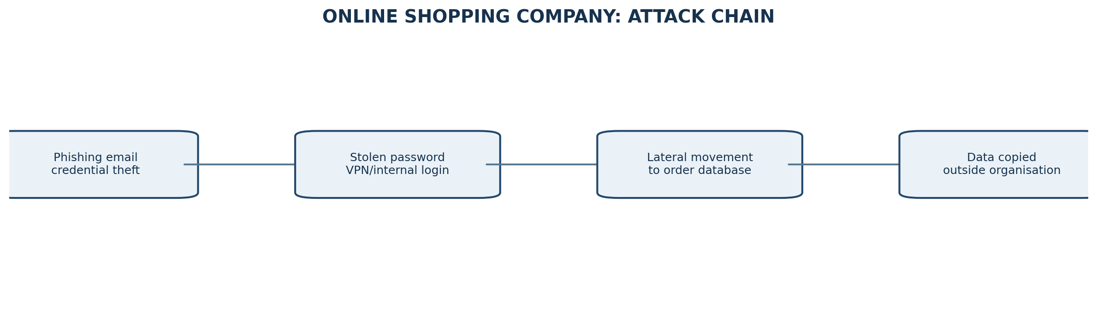
Figure 2. Simplified attack chain.

1. Classification of network threats
Threat | Meaning and relevance to this case | Passive or active
Phishing | A deceptive email tricks the support agent into revealing a password or opening a malicious link. | Active – the attacker sends a deceptive message to cause an action.
Malware | Malicious software may be delivered through an attachment or link, or used to maintain access. The case does not confirm malware was installed. | Active.
Spoofing | An attacker may impersonate a trusted sender, domain, device or login identity. Email spoofing may support the phishing stage; it is not explicitly confirmed. | Active.
Sniffing | Capturing network traffic to obtain credentials or data. No evidence in the scenario confirms packet capture. | Usually passive when traffic is only observed.
Man-in-the-middle | An attacker secretly intercepts or alters communication between two parties. Not established by the facts given. | Active if traffic is altered; interception alone can be passive.
Denial of service | Flooding a service to make it unavailable. No service outage is described. | Active.
SQL injection | Malicious SQL input manipulates a database query. No evidence says the attacker exploited an application input field. | Active.
Insider threat | A trusted employee intentionally or accidentally misuses access. The initial agent was deceived; there is no evidence the employee colluded. | Can be accidental or intentional; the employee's mistake is a human weakness, not proof of a malicious insider.

The confirmed threats are phishing and unauthorised credential use, followed by lateral movement and data exfiltration. Malware, spoofing, sniffing, man-in-the-middle, denial of service and SQL injection are possible threat categories, but should not be claimed as confirmed without evidence.

2. Passive versus active threats
- Passive threats observe or collect information without directly changing system resources. Sniffing/eavesdropping is the clearest example.
- Active threats attempt to alter, disrupt, impersonate or gain unauthorised access. Phishing, malware execution, spoofing, SQL injection and denial of service are active.
- Some techniques can have both forms: a man-in-the-middle attacker may only observe traffic (passive) or modify it (active). Insider activity depends on whether it is observation, accidental disclosure or deliberate misuse.

3. Attack-chain analysis
Stage | Threat / action | Weakness exploited | CIA impact | Control to stop or detect
1. Phishing email | Phishing; possibly sender spoofing or malicious attachment | Low security awareness; weak email filtering; users may trust display names or links | Confidentiality: password exposed; possible integrity if malware runs | Secure email gateway, DMARC/SPF/DKIM, attachment sandboxing and recurring phishing-awareness training.
2. Stolen password used to log in | Credential abuse / account takeover | Password-only authentication; reused or weak password; no adaptive access checks | Confidentiality and integrity: attacker enters internal network | MFA or phishing-resistant passkeys; conditional access; VPN login alerts and rate limits.
3. Movement to order database | Lateral movement; possible privilege escalation | Flat network; excessive permissions; exposed admin services; poor segmentation | Confidentiality and integrity: database becomes reachable and potentially modifiable | Segment support systems from databases; least privilege; privileged access management; EDR and east-west traffic monitoring.
4. Data copied externally | Data exfiltration; potentially encrypted or covert transfer | Weak egress filtering; broad database export rights; no data-loss monitoring | Confidentiality: customer data leaves company control | DLP, database activity monitoring, outbound proxy controls, alerting on large or unusual transfers.

4. Likely threat actor
The most likely actor is a cybercriminal or financially motivated criminal group. Stealing customer data can support identity fraud, resale, extortion or other financial gain. A nation-state actor is less likely because the scenario gives no espionage or strategic-targeting evidence. A hacktivist is less likely because no political or ideological motive is stated. An insider is not established: the support agent appears to have been tricked rather than deliberately assisting the attacker.

5. Technical versus human/procedural weaknesses
- Human/procedural: the support agent trusted a phishing message; security-awareness training may be inadequate; password-handling and incident-reporting practices may be weak.
- Technical: lack of MFA, weak VPN controls, flat internal network, excessive database permissions, insufficient endpoint monitoring and weak outbound data controls.
- The incident requires both kinds of remediation. Training alone cannot prevent account takeover, and technology alone cannot remove every social-engineering risk.
Conclusion: The confirmed path is a credential-based intrusion ending in data theft. Layered email security, MFA, segmentation, least privilege, monitoring and DLP would break the chain at multiple points.

QUESTION 3 – THREAT INTELLIGENCE: FROM LOGS TO ACTION
Threat intelligence is evidence-based knowledge about threats, threat actors, their methods, indicators and likely intentions. It is analysed and placed in context so that an organisation can make security decisions.

1. Data, information and intelligence
- Raw data: an unprocessed observation, such as one firewall event showing a failed VPN login from an IP address.
- Information: data organised to show meaning, such as 300 failed logins in ten minutes from the same external IP.
- Threat intelligence: information enriched with context and an assessment, such as the IP is also listed in a current credential-stuffing campaign; therefore the activity is likely hostile and requires a defined response.
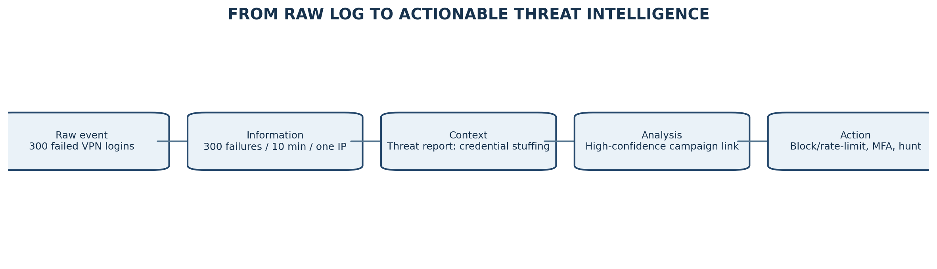
Figure 3. Converting a raw event into an actionable decision.

2. Step-by-step conversion of the example
- Collect the event: the firewall records 300 failed VPN logins from one external IP within ten minutes.
- Structure it: group events by source IP, time window, target account, VPN gateway and result. This turns separate log lines into a clear pattern.
- Enrich it: compare the IP, time and behaviour with trusted threat-sharing reports, internal incident history, reputation feeds and geolocation/ASN context.
- Correlate it: the same IP is reported in a credential-stuffing campaign. The repeated login failures are consistent with automated password guessing across accounts.
- Analyse and assess: determine confidence, likely objective, affected accounts and business risk. Check whether any login succeeded and whether MFA challenges were triggered.
- Recommend action: rate-limit or temporarily block the source where safe, enforce MFA, reset exposed credentials if indicated, inspect successful logins, and hunt for the same pattern across other gateways.
The key difference is that an IP reputation entry alone is not a complete conclusion. The analyst combines it with local evidence, checks confidence and recommends an action.

3. Characteristics of good threat intelligence
Characteristic | Explanation in this case
Timely | The campaign information and IP reputation must be current; attackers change infrastructure quickly.
Accurate | The IP and campaign association should be validated using reliable sources and corroborating evidence.
Relevant | The intelligence must apply to the company's VPN, users, geography, technology and likely exposure.
Contextual | It should explain why 300 failures matter, what credential stuffing is, and whether any account was accessed.
Actionable | It should specify practical actions, owners and urgency, not merely state that an IP is suspicious.

4. Moving from reactive to proactive security
A reactive team waits for a confirmed breach and then investigates. A proactive team uses intelligence to anticipate likely attacks and prepare before damage occurs. In this example, it can search VPN logs for the campaign's other indicators, strengthen MFA, review password reuse exposure, tune rate limits and monitor targeted accounts before a successful login occurs.

5. Benefits and limitations
Benefits | Limitations / ways to manage them
Earlier warning of campaigns and malicious infrastructure. | False positives may block legitimate users; validate indicators and use confidence scores.
Faster triage through enrichment and correlation. | Information overload can overwhelm analysts; prioritise by relevance and automate filtering.
Better threat hunting and detection rules. | Stale indicators may no longer be malicious or may be reassigned; apply expiry times and refresh feeds.
Improved incident response and risk-based investment. | Sources can be incomplete, biased or inaccurate; compare multiple trusted sources.
Better sharing and coordination across organisations. | Sharing may expose sensitive information or create legal/privacy issues; apply handling rules and minimise data.

Conclusion: Threat intelligence is not simply a list of suspicious IP addresses. It is validated, contextual knowledge that helps the security team decide what to monitor, prevent and investigate.

QUESTION 4 – STRATEGIC, TACTICAL AND OPERATIONAL INTELLIGENCE
A competitor's point-of-sale (POS) malware breach is a warning that the retail sector may be facing a similar campaign. The retailer should translate that warning into different outputs for leaders, the SOC and technical responders.
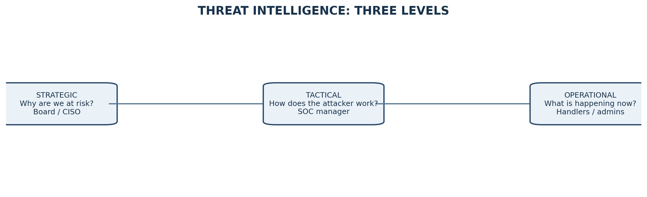
Figure 4. Three intelligence levels and their main audiences.

1. Comparison of the three types
Type | Question answered | Audience | Time horizon | Typical sources | Deliverable for this case
Strategic | Why is the organisation at risk, and what decisions or investments are needed? | CISO, board and senior leadership | Long term: months to years | Industry reports, business risk assessments, regulator advisories, sector sharing groups and trend analysis | A board risk briefing on POS malware trends, likely business impact, exposure of stores and recommended investment.
Tactical | How does the attacker operate, and what techniques should defenders understand? | SOC manager, security architects and detection engineers | Medium term: weeks to months | Incident reports, malware analysis, MITRE ATT&CK mappings, forensic reports and trusted research | A TTP report explaining how stolen vendor credentials are used to access POS management systems, move laterally and deploy malware.
Operational | What is happening or likely to happen now, and what must responders do? | Incident handlers, threat hunters and network administrators | Short term: hours to days, sometimes weeks | Live alerts, partner warnings, threat feeds, internal telemetry, incident communications and indicators | An urgent warning with suspected campaign timing, affected systems, malicious domains/IPs/hashes where verified, and immediate hunt/block steps.

2. Classification of the four items
Item | Classification | Reason
Annual report on ransomware trends in retail | Strategic | It describes long-term sector trends and supports executive risk and investment decisions.
Description of how the attacker moves from stolen vendor credentials to POS servers | Tactical | It explains attacker techniques and methods that defenders can map to controls and detections.
Advance warning of a planned attack on the retailer's holiday sales | Operational | It is a time-sensitive warning about a specific likely event requiring immediate preparation.
List of malicious domains | Operational | It provides current technical indicators that responders can block, search for or monitor. (A long-term indicator study could also inform tactical work, but the immediate list is operational.)

3. Why all three types are needed
- If the retailer uses only strategic intelligence, leaders may understand the risk but SOC teams will not know which behaviours to detect or which domains to investigate.
- If it uses only tactical intelligence, the organisation may understand attacker methods but fail to prioritise investment, business continuity and board-level risk.
- If it uses only operational intelligence, teams may block individual indicators but miss the wider campaign, attacker methods and long-term weaknesses. Indicators also change quickly.
Recommended approach: combine the three levels. The board approves risk reduction and resilience; the SOC converts attacker methods into detections; responders use current warnings and indicators to investigate and contain activity.
QUESTION 5 – THREAT INTELLIGENCE LIFECYCLE AND SAAS APPLICATIONS
Requirement: “Are we likely to be targeted by credential-stuffing and ransomware groups in the next six months?” This is a priority intelligence requirement (PIR) becauseidentifies a decision the company needs to make and a defined time period.
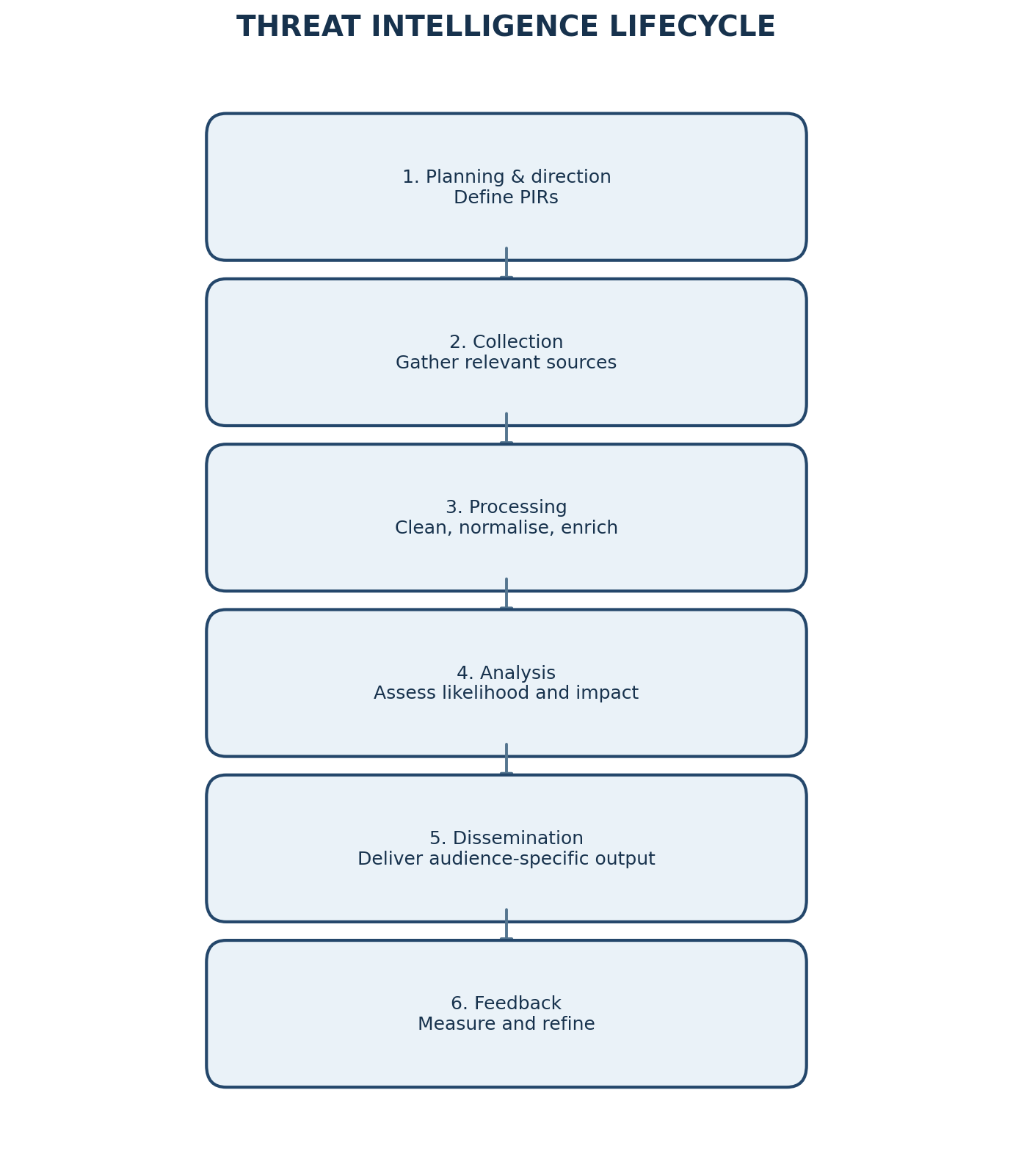
Figure 5. The six phases of the threat intelligence lifecycle.

1. Planning and direction
Clarify the business decision, scope, owners and time period. Identify critical assets such as customer login services, identity providers, cloud workloads, source-code repositories, backups and production databases.
Example PIRs:
- PIR 1: Which credential-stuffing groups or campaigns have targeted SaaS providers similar to us during the last six months, and what evidence suggests they may target us in the next six months?
- PIR 2: Which ransomware groups target our cloud technology, sector, geography or third-party providers, and what access methods do they commonly use?
- PIR 3: Which of our exposed services, identities or suppliers match the methods used by those groups?
Tools/outputs: stakeholder interviews, asset inventory, risk register and intelligence requirements matrix. Output: approved PIRs, collection plan, priority assets, reporting schedule and decision owners.

2. Collection
Gather only information relevant to the PIRs. Sources may include internal authentication and endpoint logs, cloud audit logs, SIEM/EDR alerts, vulnerability scans, trusted commercial or open-source feeds, government advisories, sector ISAC reports, vendor bulletins and incident reports.
Tools/outputs: SIEM queries, cloud security dashboards, EDR, vulnerability scanners, threat-feed platforms and secure information-sharing channels. Output: collected events, indicators, reports, TTP descriptions and source metadata.

3. Processing
Convert collected material into a consistent and usable format. Remove duplicates, normalise timestamps and fields, validate indicator formats, translate where necessary, tag sources and confidence, and enrich IPs/domains/hashes with reputation and infrastructure context.
Tools/outputs: log pipelines, parsers, data enrichment services, threat-intelligence platforms and STIX/TAXII-compatible exchange. Output: cleaned, structured and deduplicated intelligence records.

4. Analysis
Analysts evaluate the reliability of sources, compare evidence, identify patterns and estimate likelihood and impact. They should distinguish facts from assumptions and explain uncertainty. For this SaaS company, analysis should examine exposed login endpoints, MFA coverage, password-reset flows, cloud identity risks, backup resilience, exploitable vulnerabilities and third-party access.
Tools/outputs: ATT&CK mapping, attack-path analysis, risk scoring, trend analysis and analyst review. Output: an assessment of likely targeting, confidence level, priority gaps and recommended mitigations.

5. Dissemination
Deliver the right detail to the right audience in a usable format. Executives receive a short risk briefing; the SOC receives detection logic and campaign patterns; incident responders receive current indicators and containment steps; engineering teams receive patch and configuration priorities.
Use the Traffic Light Protocol (TLP) to communicate permitted sharing. TLP:RED is restricted to named recipients and must not be shared further. TLP:AMBER permits limited sharing within the recipient's organisation and, where appropriate, its clients on a need-to-know basis. TLP:GREEN permits sharing within a community but not public release. TLP:CLEAR permits public distribution. Follow the current FIRST TLP standard and any source-specific legal restrictions; TLP is a sharing label, not a classification of truth or severity.
Tools/outputs: secure reports, ticketing systems, SIEM/SOAR work queues, dashboards and briefings. Output: audience-specific reports, alerts, detection rules, response playbooks and prioritised actions.

6. Feedback
Ask whether the intelligence answered the PIR and led to useful action. Measure detection and response outcomes, collect analyst feedback, identify missed sources and revise collection priorities. Update or retire indicators when they expire.
Tools/outputs: post-incident reviews, analyst surveys, KPI dashboards and PIR review meetings. Output: improved requirements, source-quality ratings, revised rules and a refreshed collection plan.

2. Applications of threat intelligence in the IT industry
Application | How it helps the SaaS company
Incident response | Enrich alerts with known campaign context, identify related infrastructure and choose containment steps faster.
Threat hunting | Search identity, endpoint and cloud logs for attacker behaviours before a high-confidence alert is generated.
Vulnerability and patch prioritisation | Prioritise vulnerabilities that are actively exploited and relevant to the company's exposed technology rather than relying only on severity scores.
Third-party risk assessment | Check whether vendors have been targeted, what access they hold and whether their security controls create a route into the SaaS environment.
Executive risk reporting | Summarise likely threats, business impact, control gaps, residual risk and investment needs in language leaders can use.

3. Four measures to evaluate programme value
Measure | What it measures | How to interpret it
Mean Time to Detect (MTTD) | Average time from the start of a security incident to detection. | A downward trend suggests earlier identification; compare similar incident types.
Mean Time to Respond (MTTR) | Average time from detection to containment or response completion; define the endpoint consistently. | A downward trend suggests faster, more effective response.
Percentage of alerts enriched with intelligence | (Alerts enriched with relevant intelligence ÷ eligible alerts) × 100. | Shows integration into daily operations; quality and relevance matter more than simply maximising the percentage.
False-positive rate | (Alerts investigated and judged benign ÷ all alerts investigated) × 100. | A lower rate can reduce wasted analyst effort, but must not be achieved by suppressing true threats.

Conclusion: The lifecycle turns a broad six-month question into focused requirements, evidence collection, analysis and decisions. A useful programme is measured by better security outcomes, not by the number of feeds or indicators collected.
QUICK REVISION – KEY POINTS
- Q1: CIA = Confidentiality, Integrity, Availability. Add authentication, non-repudiation and accountability for trusted access and traceability.
- Q2: Confirmed chain = phishing → stolen credentials → internal access → lateral movement → data exfiltration. Do not claim unproven techniques as facts.
- Q3: Data is an event; information is organised facts; intelligence is contextual analysis that supports action.
- Q4: Strategic = why / long term; Tactical = how / attacker methods; Operational = what is happening now / immediate action.
- Q5: Lifecycle = planning, collection, processing, analysis, dissemination, feedback. PIRs keep collection focused.

